DIS-AM,S-Peru-Chavin Vicus-100 B.C.E.-400 C.E.

Pre-columbian ceremonial fertility idol gold tumbaga a private collection of several years . I will send a certificate of provenance Chavin - vicus 100 B.C.E. -400 A.D coast North from Peru Measure: 3.2 x 1.7'' inches excellent condition

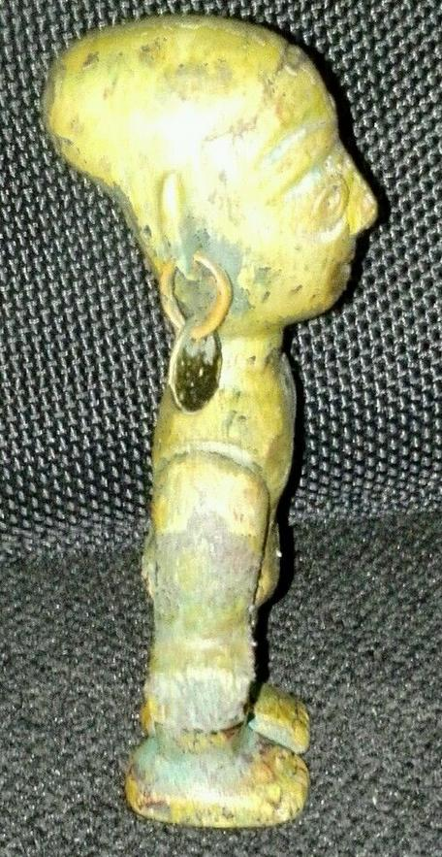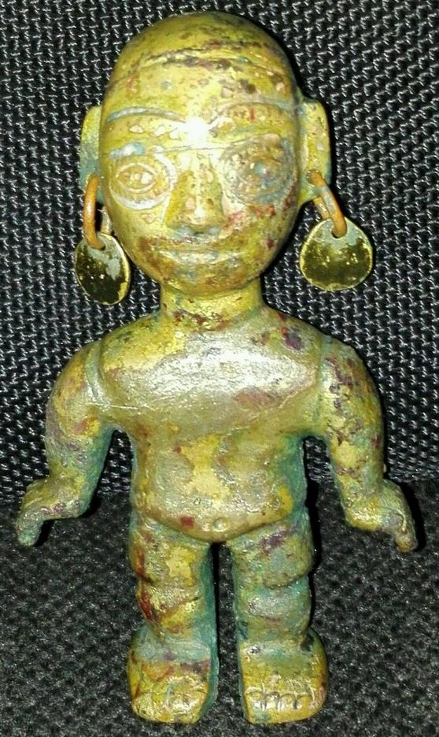 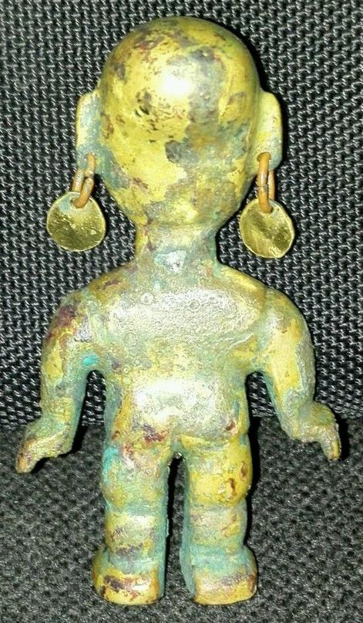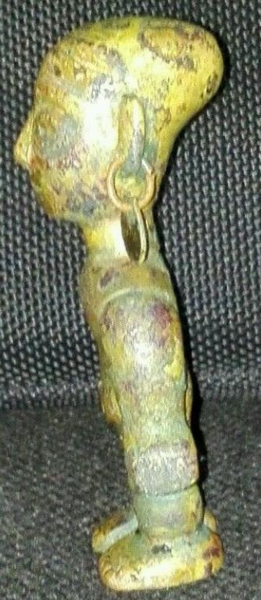

# Order details

## Sales order

Sold by [mmda.ludisa](http://myworld.ebay.com/mmda.ludisa) ( [10](http://feedback.ebay.com/ws/eBayISAPI.dll?ViewFeedback&userid=mmda.ludisa) )

### Delivery package 1 of 1

Estimated delivery Monday, Mar 21, 2016

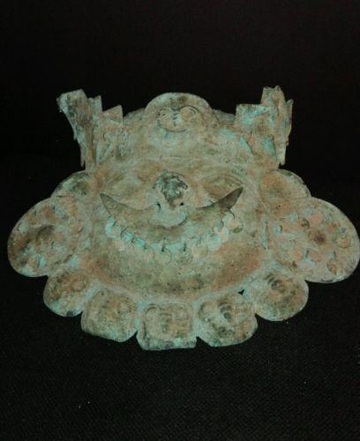

#### [PRE-COLUMBIAN MASK OF COPPER MOCHE](http://www.ebay.com/itm/252309300914)

|  |  |
| --- | --- |
| Item price | $550.00 |
| Quantity | 1 |
| Item number | 252309300914 |
| Shipping service | Standard Shipping |

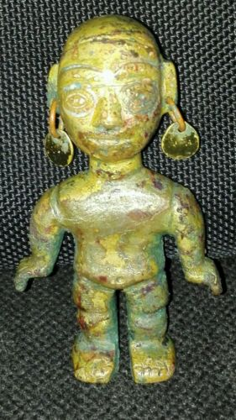

#### [PRE-COLUMBIAN IDOL GOLD TUMBAGA CHAVIN -VICUS](http://www.ebay.com/itm/252309372325)

|  |  |
| --- | --- |
| Item price | $500.00 |
| Quantity | 1 |
| Item number | 252309372325 |
| Shipping service | Standard Shipping |

## Shipping address

Ralph J Coffman Jr

149 Atlantic Ave

Swampscott MA 01907-2427

United States

## Order total

|  |  |
| --- | --- |
| Subtotal | $1,050.00 |
| Shipping | $30.00 |

**Total**

$1,080.00